21st Century Metaphysics
Erin O'Hara
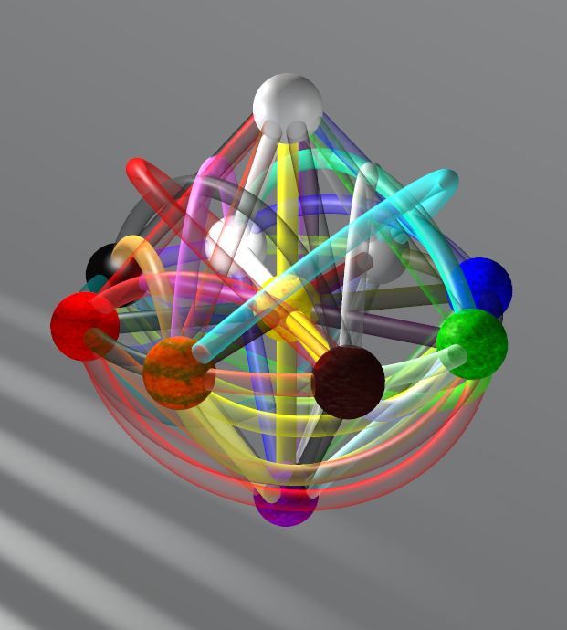

Chapter One: 1 + 1 = 1, An Introduction To Love
An introduction to a new type of math.

An Intuitive Definition Of Love
Love is a system of math designed to be useful in the analysis of qualitative information. It works well with things like emotions, feelings, and even metaphysics. A brief, non-formal, introduction is provided here, followed by a short formal introduction. If you're ok with the informal introduction, you can skip the formal introduction . It just says the same thing in a different way.

A number in Love does not represent the counting of things, but rather represents the type of thing. For example, water is a type of thing, regardless of how much water we have. We can assign a Love number to water and use that number every time we mean water. The assignment of numbers is arbitrary in the sense that one analysis may assign water to the number 1, and another unrelated analysis may assign something completely different to the number 1, say dogs. Assigning a Love number to a thing can be thought of as declaring that number to be a synonym for that thing.

When a new thing comes along, we assign it to a new number. For example, in an analysis where water has been assigned to 1, we can assign dirt to the next number, 2.

Once we have multiple numbers representing different things, we immediately combine those things to produce a new thing, and therefore a new number. For example, in an analysis where 1 is water and 2 is dirt, we combine them together to get a new thing, mud, and assign mud to the number 3.

The numbers that represent uncombined things are called Simple Numbers. The sequence of simple numbers is 1, 2, 4, 8, 16, 32, 64, etc. as well as -1, -2, -4, -8, -16, -32, -64, etc. All numbers that are not simple numbers are Compound Numbers. 3, 5, 6, 7, 9, 10, 11, 12, etc are all examples of compound numbers, as are -3, -5, -6, -7, -9, -10, -11, -12, etc.

Love allows for functions, which are a set of operations performed on one or more numbers and providing one or more numbers as a result.

The key point to all of this is a number in Love represents a type of thing, not the amount of that thing. For example, if we assign water to the number 1 and add more water to it, we still have only water. This is represented in Love as 1 + 1 = 1. Similarly, if we assign dirt to 2 and add more dirt to it, we have only dirt: 2 + 2 = 2. It is only when we mix the simple numbers to form a compound number that we get a new number. Water plus dirt equals mud. 1 + 2 = 3.

A Formal Definition Of Love
Axiom 0: 0 is a number.

The = Operator
Axiom 1: The = operator converts its arguments into a Boolean true or false value. The result is true if the two arguments are the same number, false otherwise.

The + Operator
Axiom 2: For any number, + is the identity operator, e.g. X + X = X.
Axiom 3: Adding zero to a number is the identity operator, e.g. X + 0 = X, 0 + X = X.
Axiom 4: For two different numbers, + produces a new number when X and Y are not 0, e.g. X + Y = Z.
Nomenclature 1: In X + Y = Z, Z is called a Compound Number.
Nomenclature 2: Any number that is not a Compound Number is called a Simple Number

The – Operator
Axiom 5: The – operator behaves as follows: X + Y – Y = X

Negative Numbers
Axiom 6: All numbers have negative counterparts.,
Nomenclature 3: Negative numbers have a – sign in front of the number, e.g. -X.
Axiom 7: -0 = 0. Axiom 8: X + -X = 0. Axiom 9: 0 – X = -X.
Axiom 10: 0 – -X = X.

Mutation Operator
Axiom 11: The Mutation Operator, M, transforms 0 into a new Simple Number, e.g. M(0) = X, where X is a Simple Number and does not equal any existing Simple Number.
Axiom 12: The binding power of the Love operators are, from highest to lowest: M(), + and -, =.
Nomenclature 4: Results from executing the mutation operator are labeled with numbers that in regular math would be called powers of 2, e.g. 1, 2, 4, 8, 16, 32...
Nomenclature 5: After using the Mutation Operator to create a new Simple Number, all existing Simple Numbers are combined with the new Simple Number to produce new Compound Numbers. Compound Numbers are labeled based on the sequence of numbers from regular math, skipping over powers of 2, e.g. 3, 5, 6, 7, 9, 10, 11...
Nomenclature 6: An extension to the nomenclature for representing numbers is to add a subscript indicating quantity, e.g. 1₁ + 1₁ = 1₂, and 1₁ + 2₁ = 3₂. Doing this enables Love to replicate the capabilities of standard math. In cases where the components of a Compound Number are not equally represented in the Compound Number, the excess forms its own number, separated from the rest of the Compound Number by a period, e.g. 1₁ + 1₁ + 2₁ = 3₂.1₁ and 1₄ + 2₁ = 3₂.1₃. This method of subscripts and periods is not used in this document, as it is not needed for our purposes.
Note 1: Because all numbers have negative counterparts, we may say M(0) = X, -X.

Functions
Axiom 13: Functions take the form of Name(input numbers) = output numbers.
Note 2: Love Functions take a set of numbers, perform an operation on them, and return a new set of numbers. Because Love often deals with subjective experiences, the bodies of the functions can be undefined. This means we don't know why or how a set of transformations take place, only that they do take place. But if the steps of the function can be explained, Love can represent those steps.

Example: Love And Eucharistic Theology
The follow discussion provides examples of how Love can be used to analyze metaphysical doctrine, translating it into numbers. In this analysis, we'll be looking at the meaning the Eucharist in various Christian religions. The definitions used here were taken from the wikipedia page on Eucharistic theologies.[i] Throughout these examples we will identify Love numbers as follows:

1 Bread | 4 Body Of Christ | 16 Soul Of Christ | 64 Fundamental Reality Of Bread | 256 Spirit of Christ | 1024 Partakers who have faith
2 Wine | 8 Blood Of Christ | 32 Divinity Of Christ | 128 Fundamental Reality Of Wine | 512 Holy Spirit

Transubstantiation
Transubstantiation is taught by the Roman Catholic Church. Here the “fundamental reality” of the the bread and wine are changed into the Body, Blood, Soul, and Divinity of Christ, while the physical traits of the bread and wine remain the same. In Love, this is expressed as the following function: Transubstantiation(192) = 60, where 192 = 64 + 128, and 60 = 4 + 8 + 16 + 32 (Compare numbers to table above)

Consubstantiation
In Consubstantiation the bread retains its substance and Christ’s glorified body comes down into the bread. This can be expressed in Love with the following function:
Consubstantiation(1) = 5, where 5 = 4 + 1

Sacramental Union
Sacramental union states that Christ's body unites with the bread and his blood unites with the wine. The Love function is:
SacramentalUnion(1) = 5, where 5 = 4 + 1 (Note Consubstantiation(1) = SacramentalUnion(1))
SacramentalUnion(2) = 10, where 10 = 2 + 8

Real Spiritual Presence
Real Spiritual presence, holds that the Spirit of Christ, and the true body and blood of Christ are received by the Holy Spirit, but only by those partakers who have faith. The Love function for this would be:
RealSpiritualPresence(1536) = 1804, where 1536 = 512 + 1024, and 1804 = 512 + 1024 + 256 + 8 + 4.

Memorialism
Memorialism states that the bread and wine are only symbolic of Christ. The Love function would be:
Memorialism(1) = 1 Memorialism(2) = 2

i http://en.wikipedia.org/wiki/Eucharistic_theologies_contrasted

